Chapter 12

1. Become familiar with idisp for greyscale and colour images. Explore pixel values in the image as well as the zoom, line and histogram buttons.

The picture is being loaded and displayed into matlab.

We also use this command in order to see the number of pixels in each side of the photo and the total size of the photo.

chess= iread('chess_grey_scale.tif');

about(chess);

idisp(chess);



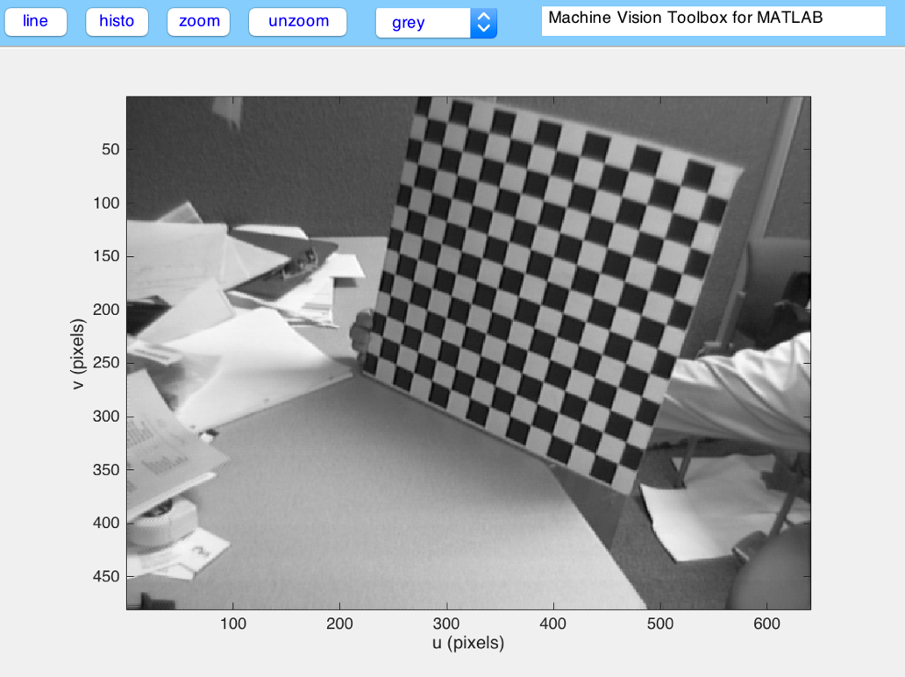

Exploring the command buttons above the picture.

We use the command zoom in order to zoom

Clicking on a random point at the photo we are able to see in what pixel of the v and u side corresponds.

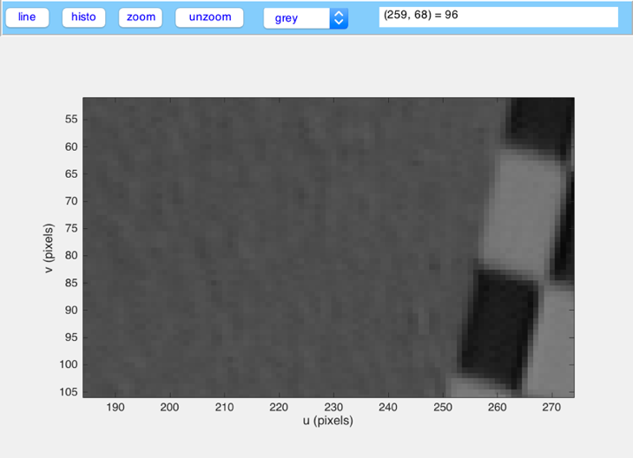

Using the command line we are able to see the greyscale of the pixels that passes throught.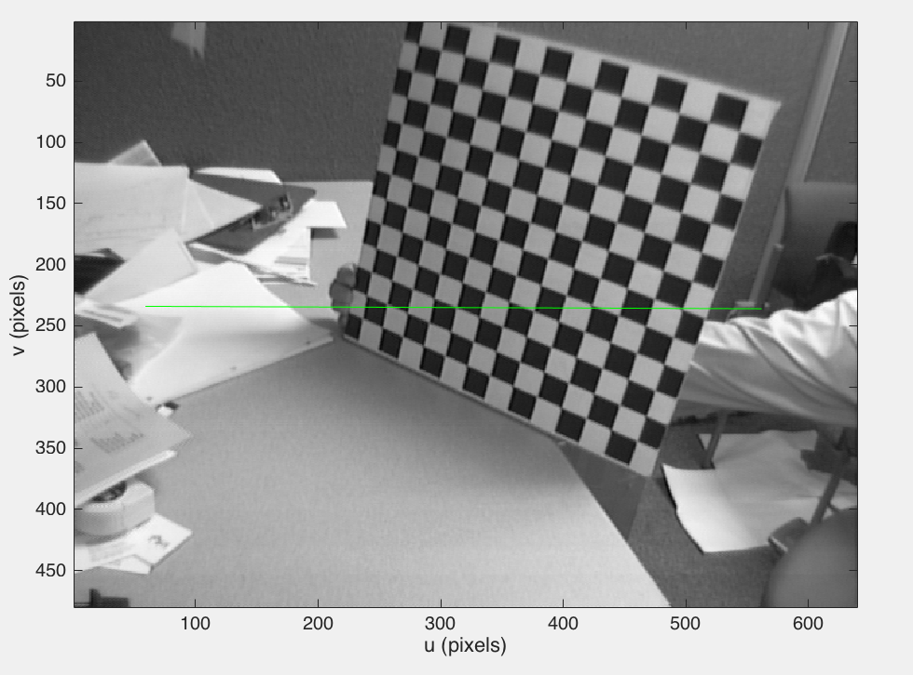

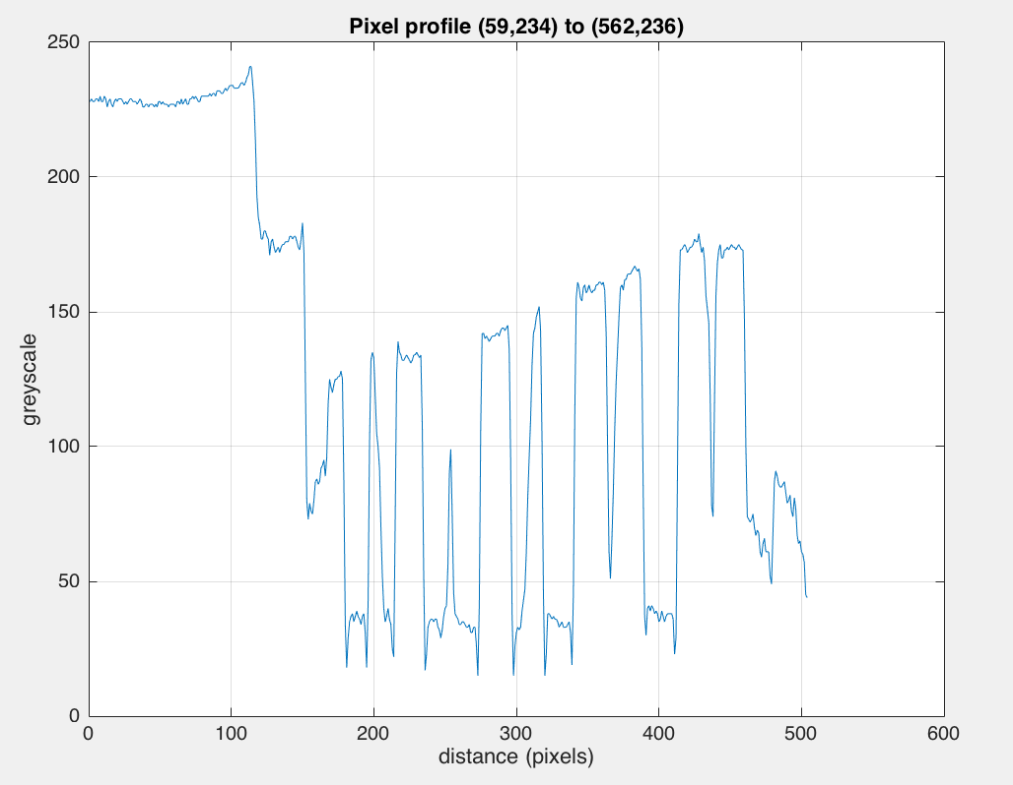

Using the histogram button we are able to see the distribution of pixels for all greylevel values.

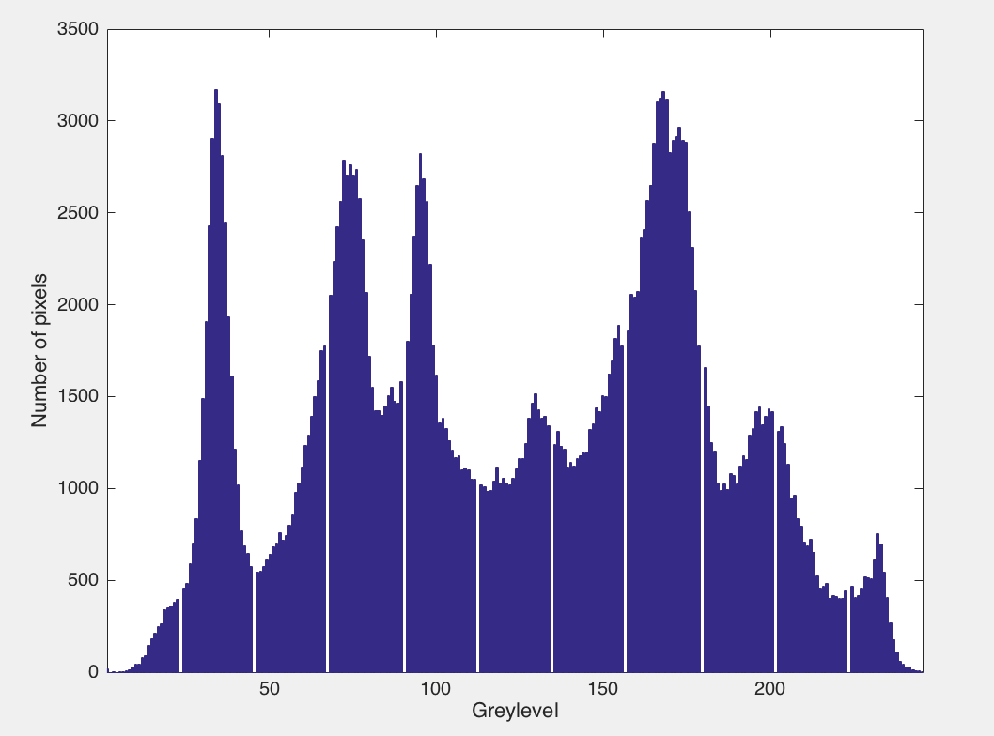

Now using a color picture and the command pix we are able to see the exact color for every pixel .

eiffel= iread('eiffel.jpg');

pix = eiffel(276,318,:)

about(pix)

rgb

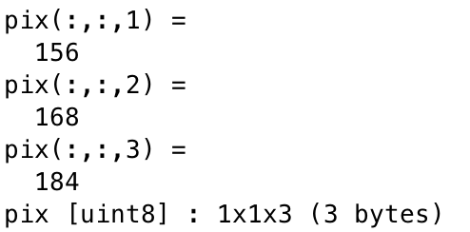

1. Grab some frames from the camera on your computer or from a movie file and display them.

cam = Movie('hst_1.mpg')

cam.size() %size of each frame

im = cam.grab('frame',60);

im2 = cam.grab('frame',300);

im3 = cam.grab('frame',500);

idisp({im,im2,im3});

cam =

320 x 240 @ 2.997003e+01 fps; 570 frames, 19.019000 sec

cur frame 1/570 (skip=1)

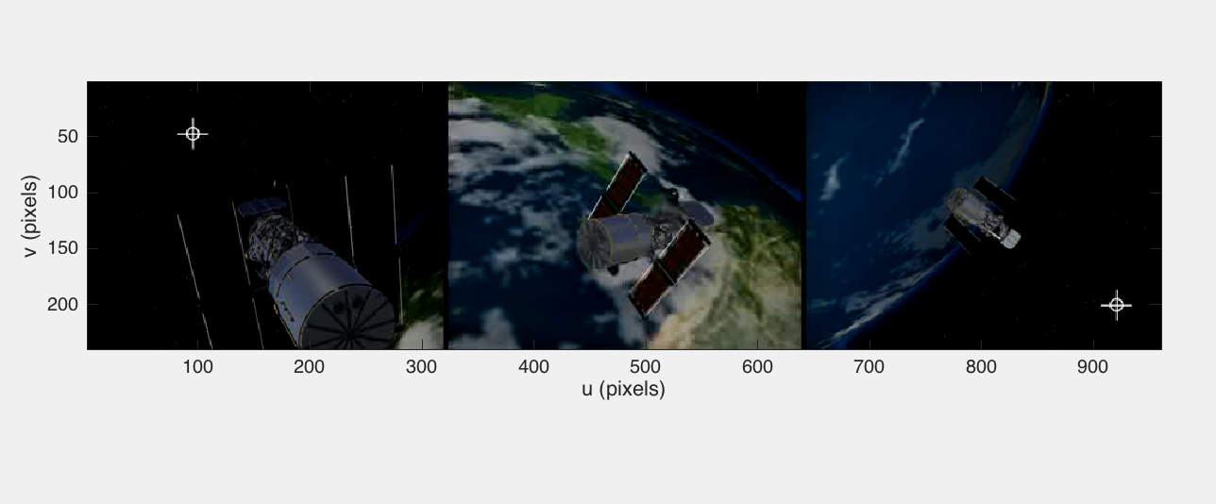

1. Write a loop that grabs a frame from your camera and displays it. Add some effects to the image before display such as “negative image”, thresholding, posterization, false colour, edge filtering etc.

We capture the frame 100 by ending the loop at the 100th frame using the command cam.grab

cam = Movie('video_iphonese.mp4')

for i =1:100

im = cam.grab;

end

figure

idisp(im);

title('Image Captured')

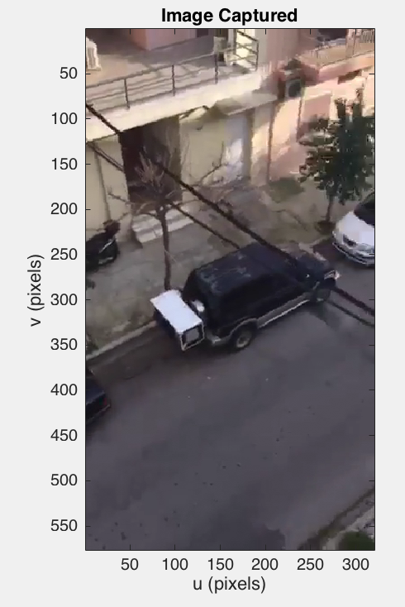

%% thresholding

imthresh = (im >= 30) & (im<= 80);

figure

idisp(imthresh);

title('Thresholding')

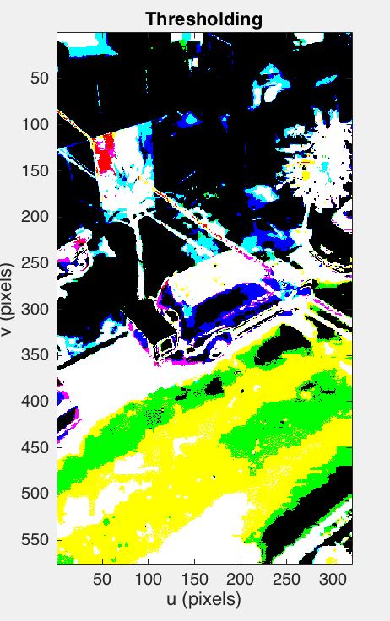

%% negative

imneg = iint(ones(size(im))*255) - im;

figure

idisp(imneg);

title('Negative')

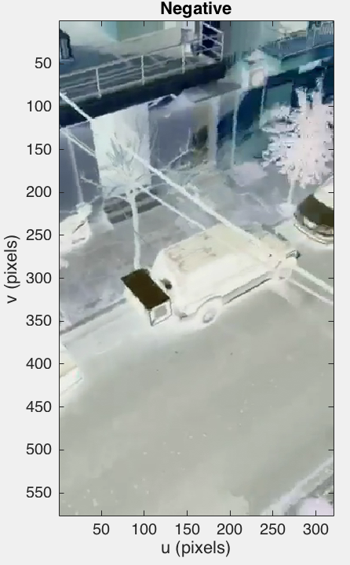

%% posterization

figure

image_grey = imono(im);

idisp(image_grey/16);

title('Posterization')

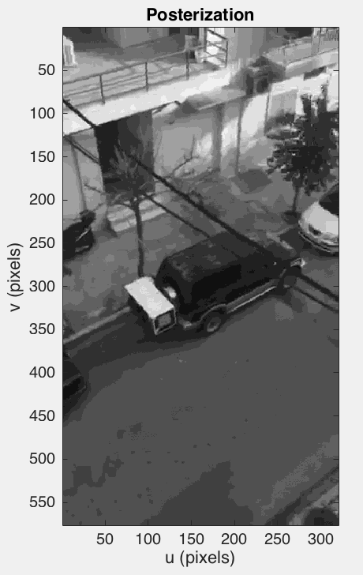

%% edges

[imx,imy] = isobel(im);

ims = imx+imy;

figure

idisp(ims);

title('Edges')

close(cam);

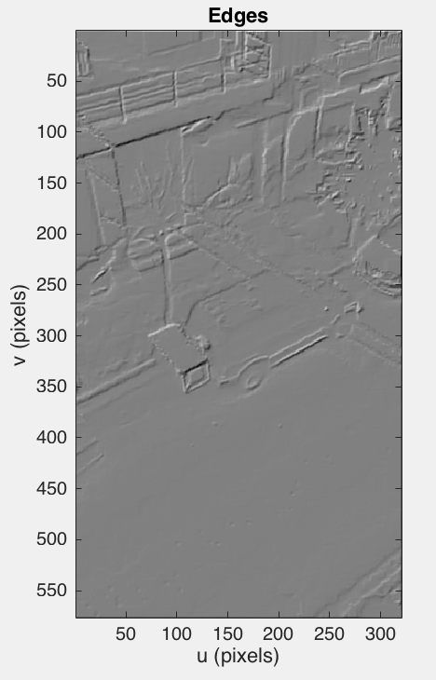

1. Motion detection

a)  Write a loop that performs background estimation using frames from your camera. What happens as you move objects in the scene, or let them sit there for a while? Explore the effect of changing the parameter σ.

cam = Movie('video_se1.mp4');

bg = cam.grab();

sigma = 2; %higher sigma, background updated better

while 1

im = cam.grab;

if isempty(im),

break;

end

d = im-bg;

d = max(min(d, sigma), -sigma);

bg=bg+d;

idisp(bg); drawnow

end

close(cam);

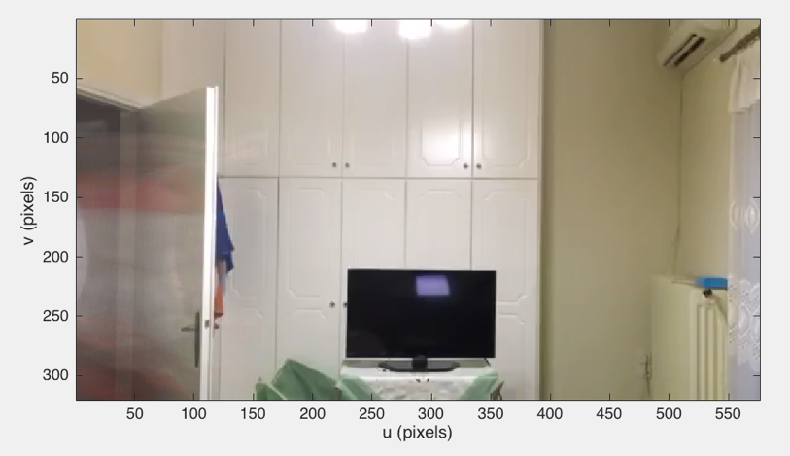

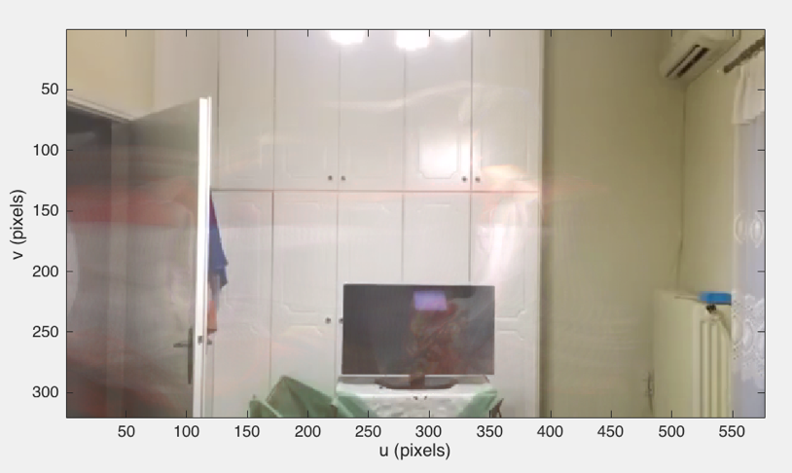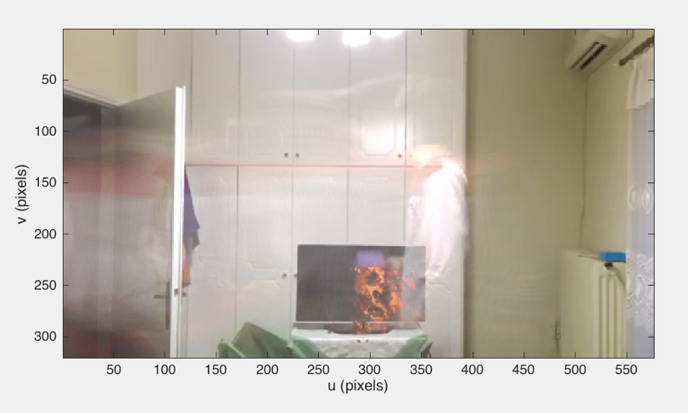

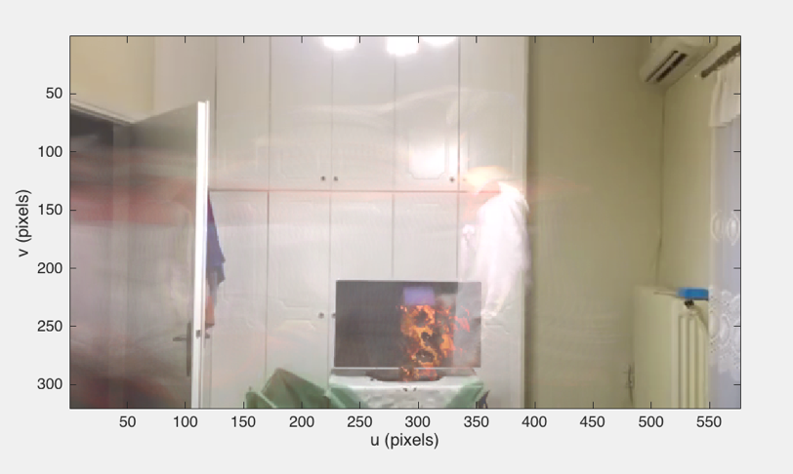

We notice that as I let the object sit somewhere for a while it becomes part of the background.

Higher sigma

Using a higher sigma the background is worst.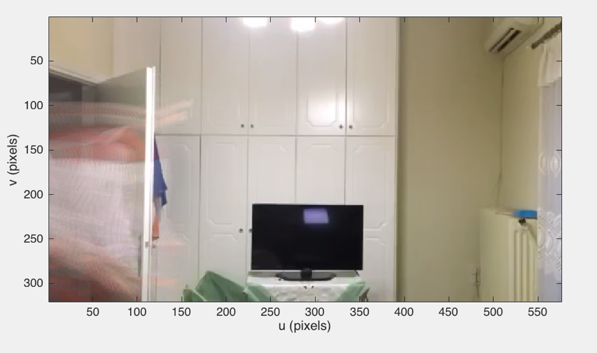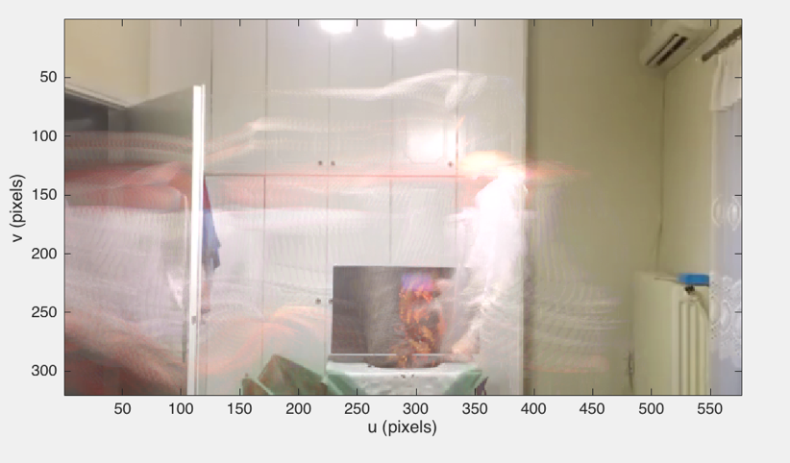

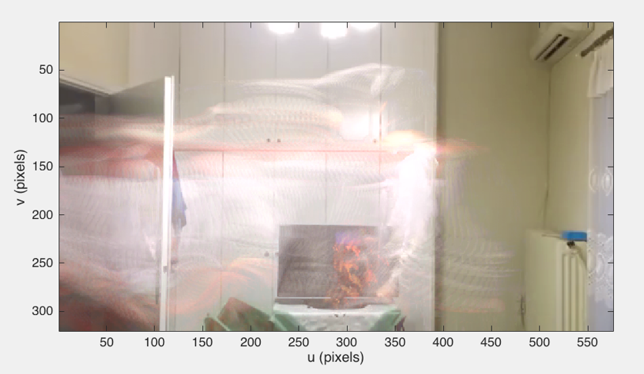

Lower sigma

Using a lower sigma the background is updated much better.

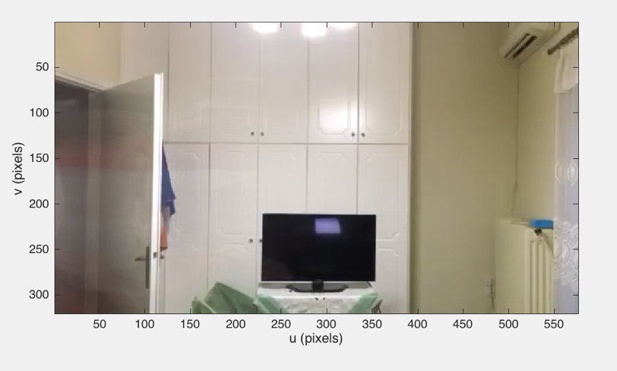

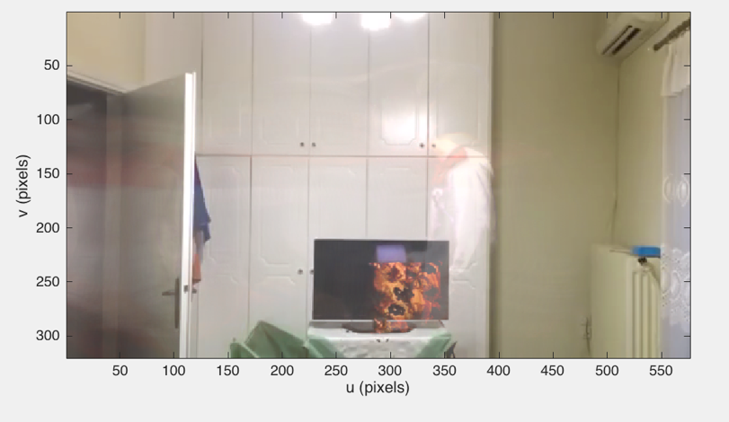

b)  Modify the *LeftBag* example on page 298 and highlight the moving people.

Subtracting the scene from the estimated background creates an image where pixels are bright where they are different to the background.

cam = Movie('LeftBag.mpg');

bg = cam.grab();

sigma = 2;

for i = 1 : 500

im = cam.grab();

if isempty(im)

break;

end

d = im-bg;

fg = max(min(d, sigma), -sigma);

bg = bg + fg;

% d1 = (d >= 30) & (d<= 80);

idisp(d,'invsigned');

drawnow;

end

close(cam);

Using the same video as before we observe that only the movement is being highlighted.

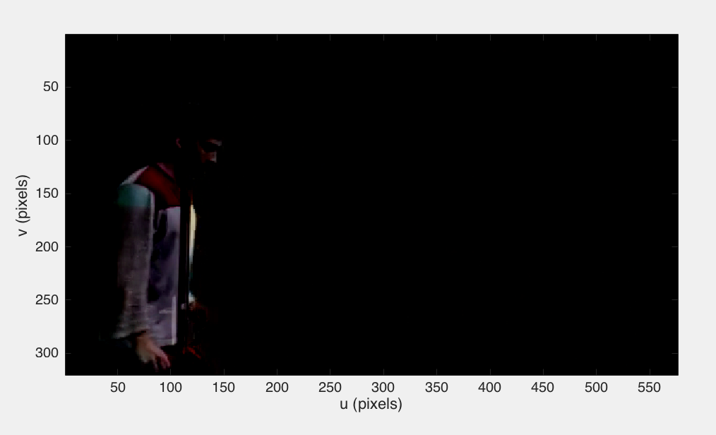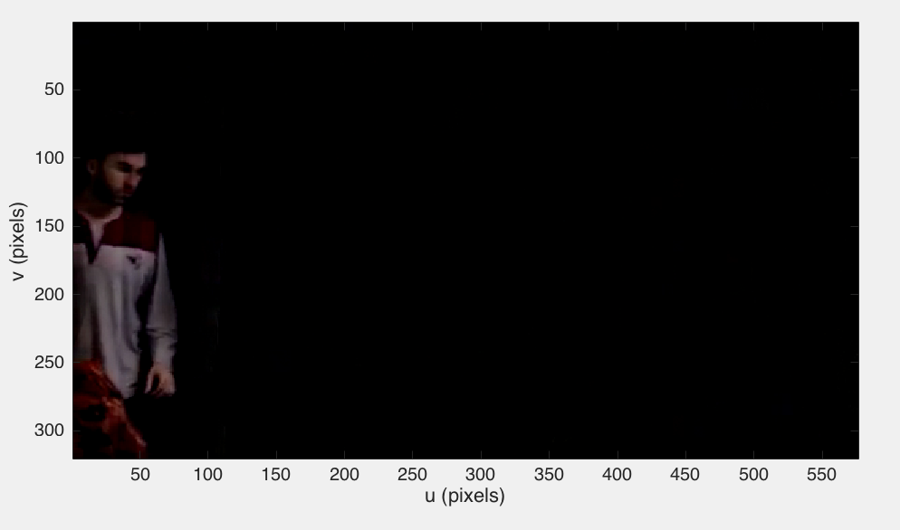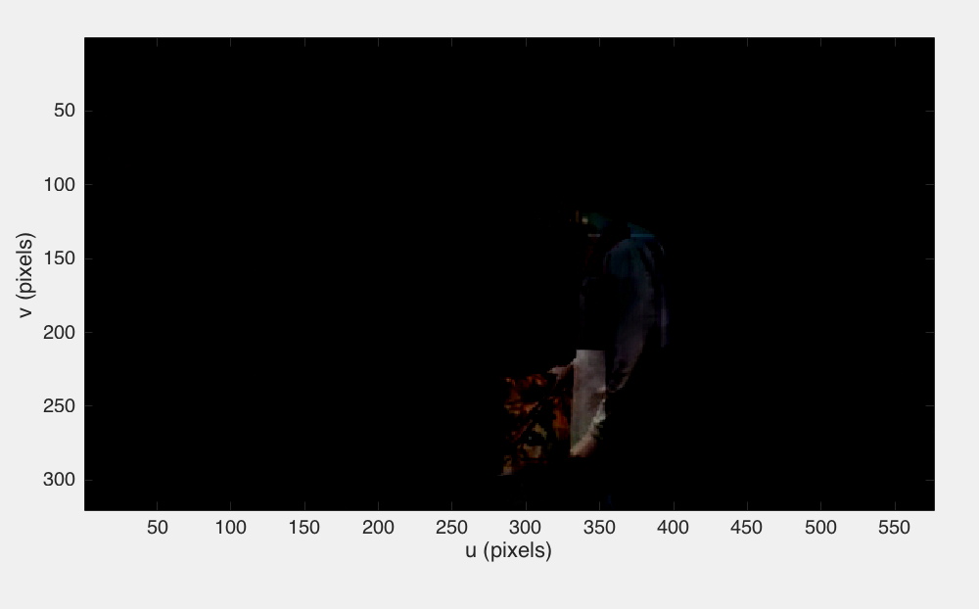

c)  Combine motion detection and chroma-keying, put the moving people from the lobby into the desert.

clc;

clear all;

cam = Movie('LeftBag.mpg');

img = iread('desert.jpg');

bg = cam.grab();

img = isamesize(idouble(img), bg);

sigma = 2;

while 1

im = cam.grab();

if isempty(im)

break;

end

diff = im-bg;

fg = max(min(diff, sigma), -sigma);

bg = bg + fg;

fg = diff > 40;

idisp(fg.*idouble(im) + (1-fg).*img);

drawnow;

end

close(cam);

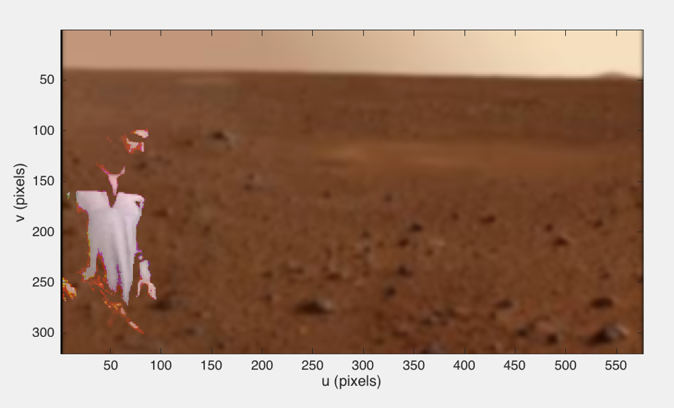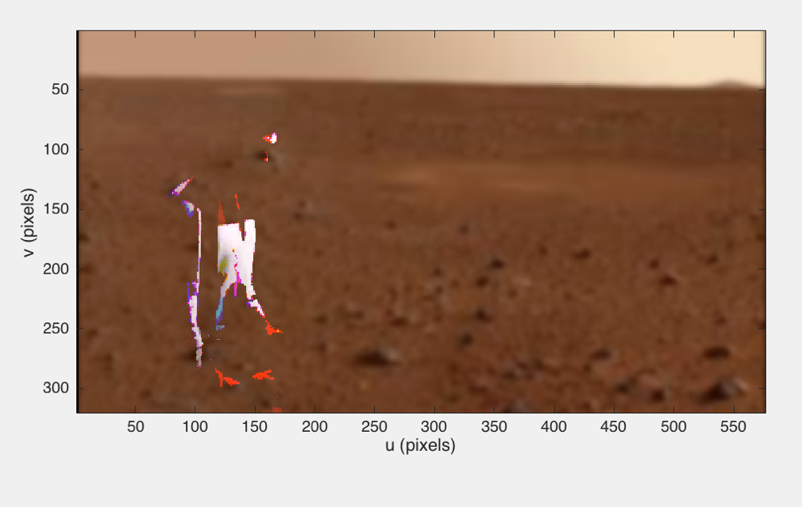

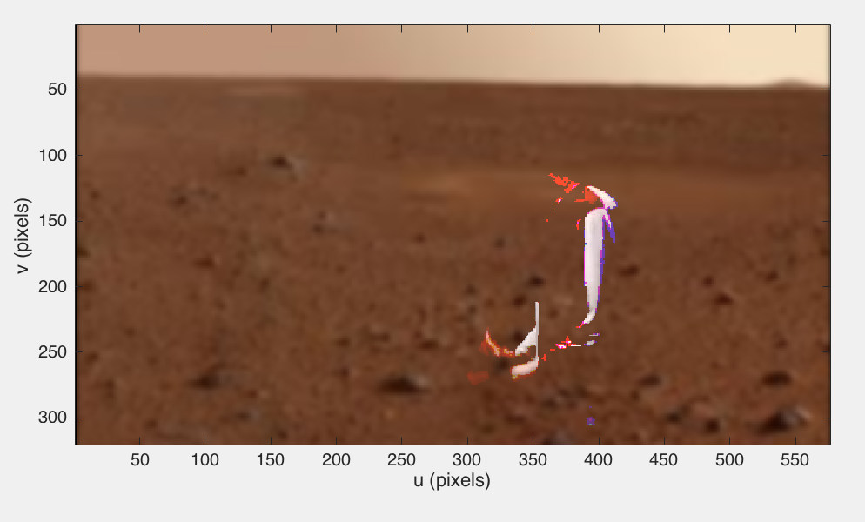

1. Convolution
2. Compare the results of smoothing using a 21×21 uniform kernel and a Gaussian kernel. Can you observe the ringing artefact in the former?

After reading the picture and creating the kernels , we convolve the picture with each kernel.

lena = iread('castle.jpg', 'double');

%% uniform kernel

K = ones(21,21) / 21^2; %21x21 uniform

about(K)

im1= iconv(K, lena);

% gaussian kernel

K = kgauss(10); % s=3.2 to become 21x21

about(K)

im2= iconv(K, lena) ;

idisp({im1,im2})

title('Uniform Kernel - Gaussian Kernel')

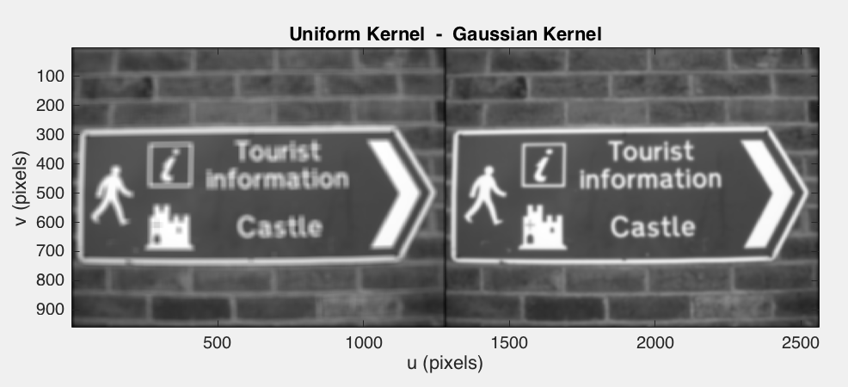

The ringing effect at the first picture is obvious.

b)  Why do we choose a smoothing kernel that sums to one?

We choose a smoothing kernel that sums to one in order to prevent the brightness of the output image from changing. The output image has the same brightness as the input image.

c)  Compare the performance of the simple horizontal gradient kernel ***K***=(−0.5 0 0.5) with the Sobel kernel.

%simple horizontal gradient kernel K

K = [-0.5 0 0.5];

im3= iconv(lena, K);

%sobel kernel

Du = ksobel;

im6=iconv(lena,Du);

idisp({im3, im6}, 'invsigned')

title('Horizontal Kernel - Sobel Kernel')

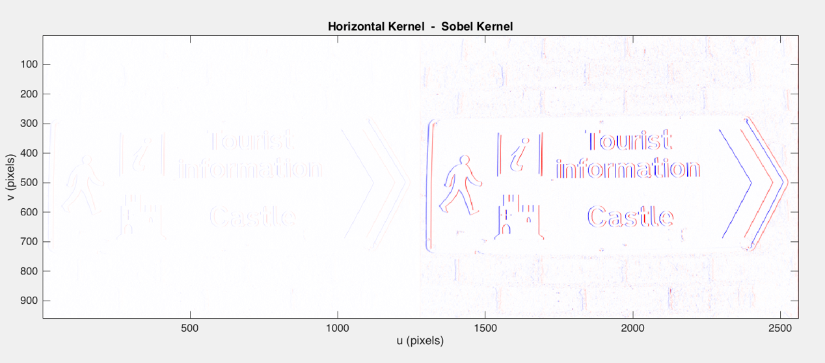

As we observe Sobel Kernel is much better and the edge detection is way more obvious.

d)  Investigate filtering with the Gaussian kernel for different values of σ and kernel size.

%% Gaussian Kernel

%for different values of sigma and kernel size

G1 = kgauss(2,2);

G2 = kgauss(4,6);

G3 = kgauss(6,6);

G4 = kgauss(7,11);

figure

idisp( iconv(lena,G1));

title('sigma=2, size=2')

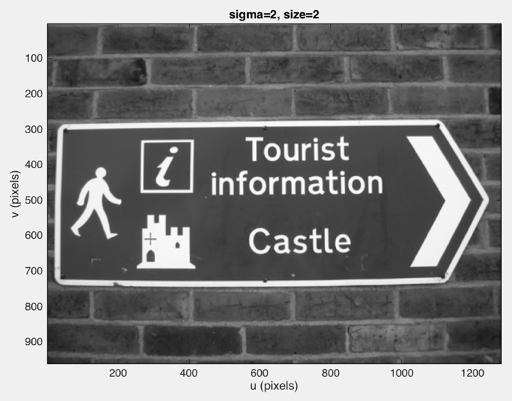

figure

idisp( iconv(lena,G2));

title('sigma=4, size=6')

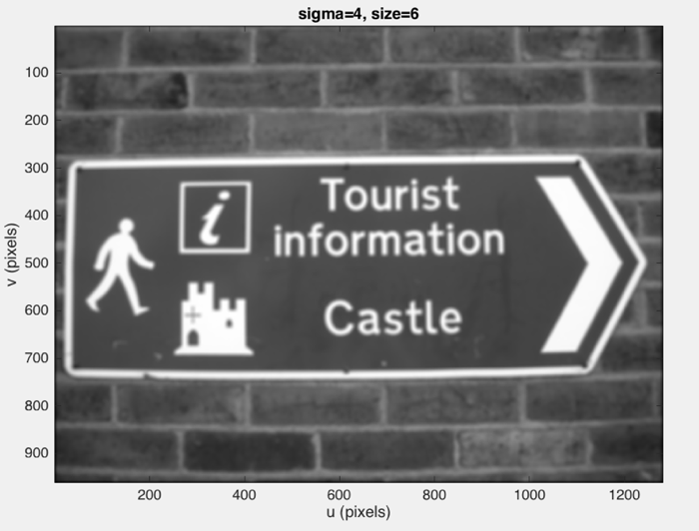

figure

idisp( iconv(lena,G3));

title('sigma=6 size=6')

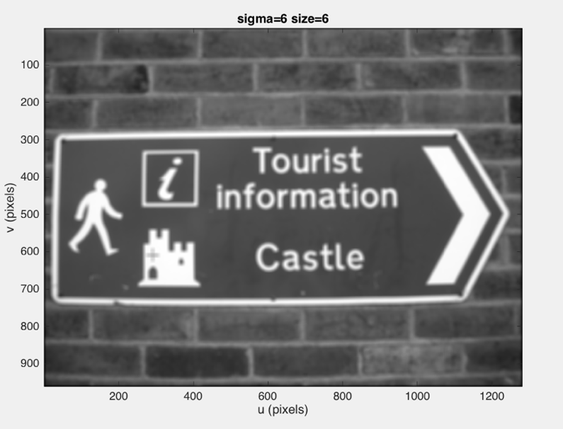

figure

idisp( iconv(lena,G4));

title('sigma=7 size=11')

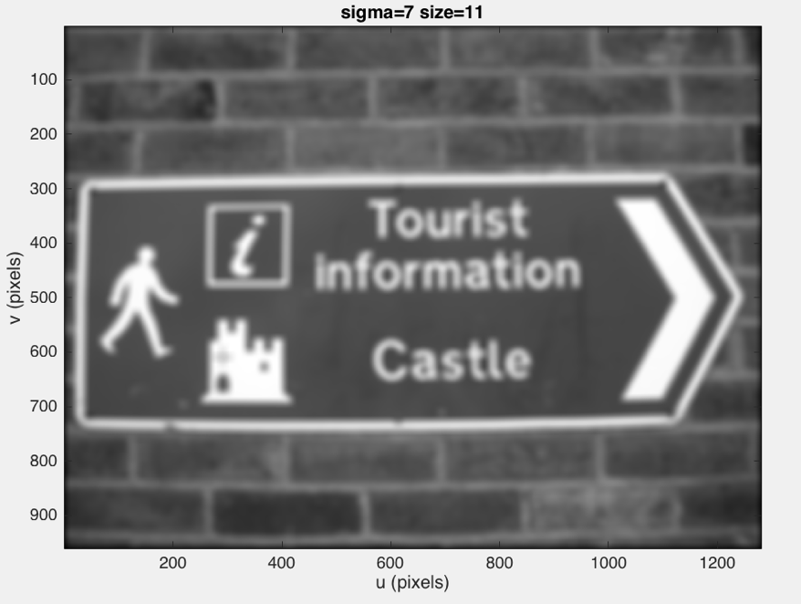

e)  Create a 31 × 31 kernel to detect lines at 60 deg.

The Sobel kernel itself can be considered as an image and rotated using irotate. To obtain angular precision generally a larger kernel is required such as that generated by kdgauss.

rotated_kd= irotate(kdgauss(5), 60*pi/180);

about(rotated_kd)

image_rotate= iconv(lena, rotated_kd);

idisp(image_rotate, 'invsigned')

rotated_kd [double] : 31x31 (7.7 kB)

After convolving the ratated Kernel with the picture the result is:

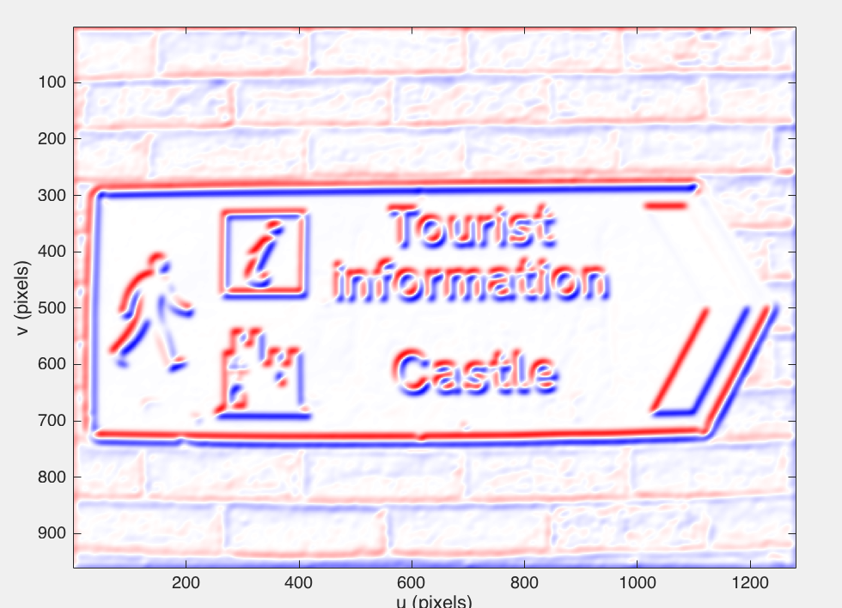

f)  Derive analytically the derivative of the Gaussian in the *x*-direction Eq. 12.2.

$$Gauss Equation=G=\frac{1}{2π}\exp\left(-\frac{u^{2}+υ^{2}}{2σ^{2}}\right)$$

$$\frac{∂}{∂u}G=\frac{∂}{∂u}\left(\frac{1}{2πσ^{2}}\exp\left(-\frac{u^{2}+υ^{2}}{2σ^{2}}\right)\right)$$

$$DoG=\frac{∂}{∂u}G=\frac{-u}{2πσ^{2}}exp\left(-\frac{u^{2}+υ^{2}}{2σ^{2}}\right)$$

g)  Derive analytically the derivative of the Laplacian of Gaussian Eq. 12.6.

$$Gauss Equation=G=\frac{1}{2π}\exp\left(-\frac{u^{2}+υ^{2}}{2σ^{2}}\right)$$

$$DoG=\frac{∂}{∂u}G=\frac{-u}{2πσ^{2}}exp\left(-\frac{u^{2}+υ^{2}}{2σ^{2}}\right)$$

$$\frac{∂^{2}}{∂^{2}u}G=\exp\left(-\frac{u^{2}+υ^{2}}{2σ^{2}}\right)\left(\frac{u^{2}}{{2πσ}^{4}}\right)+\exp\left(-\frac{u^{2}+υ^{2}}{2σ^{2}}\right)\left(-\frac{1}{2πσ^{2}}\right)$$

$$\frac{∂^{2}}{∂^{2}u}G=\exp\left(-\frac{u^{2}+υ^{2}}{2σ^{2}}\right)\left(\frac{u^{2}}{{2πσ}^{4}}-\frac{1}{{2πσ}^{2}}\right)$$

$$\frac{∂^{2}}{∂^{2}υ}G=\exp\left(-\frac{u^{2}+υ^{2}}{2σ^{2}}\right)\left(\frac{υ^{2}}{{2πσ}^{4}}-\frac{1}{{2πσ}^{2}}\right)$$

$$LoG=\frac{∂^{2}}{∂^{2}u}G+\frac{∂^{2}}{∂^{2}υ}G=exp\left(-\frac{u^{2}+υ^{2}}{2σ^{2}}\right)\left(\frac{u^{2}}{{2πσ}^{4}}-\frac{1}{{2πσ}^{2}}+\frac{υ^{2}}{{2πσ}^{4}}-\frac{1}{{2πσ}^{2}}\right)$$

$$LoG=\exp\left(-\frac{u^{2}+υ^{2}}{2σ^{2}}\right)\left(\frac{u^{2}+υ^{2}}{{2πσ}^{4}}-\frac{1}{{πσ}^{2}}\right)$$

$$LoG=\frac{1}{{πσ}^{2}}exp\left(-\frac{u^{2}+υ^{2}}{2σ^{2}}\right)\left(\frac{u^{2}+υ^{2}}{{2σ}^{2}}-1\right)$$

h)  Derive analytically the difference of Gaussian from page 310.

$$G1=\frac{1}{\sqrt{2πσ_{1}^{2}}}\exp\left(-\frac{u^{2}+v^{2}}{2σ_{1}^{2}}\right) , G2=\frac{1}{\sqrt{2πσ_{2}^{2}}}exp\left(-\frac{u^{2}+v^{2}}{2σ_{2}^{2}}\right)$$

$$diffG=G1-G2= \frac{1}{\sqrt{2πσ_{1}^{2}}}\exp\left(-\frac{u^{2}+v^{2}}{2σ_{1}^{2}}\right)-\frac{1}{\sqrt{2πσ_{2}^{2}}}exp\left(-\frac{u^{2}+v^{2}}{2σ_{2}^{2}}\right)$$

$$diffG=\frac{1}{\sqrt{2πσ_{1}^{2}σ_{2}^{2}}}\left(σ_{1}^{}exp\left(-\frac{u^{2}+v^{2}}{2σ_{1}^{2}}\right)-σ_{2}^{}exp\left(-\frac{u^{2}+v^{2}}{2σ_{2}^{2}}\right)\right)$$